Community Legal Clinic
Saturday October 5, 2013
10AM to Noon
Florin High School Library
Two Workshops to Choose From:

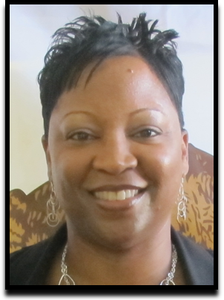
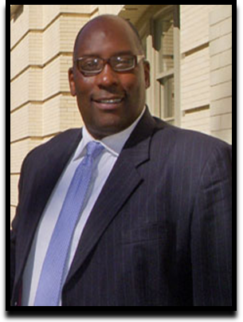

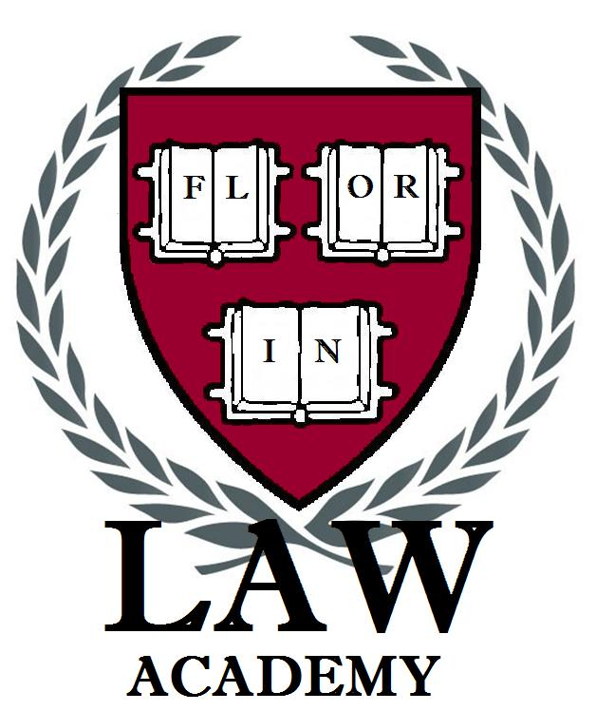

Restraining Orders
and Protecting Yourself from Domestic Violence

What does the law consider domestic violence? What can I do if I am a victim? What is the effect of a restraining order?
Workshop presented by attorney
DeLonda Coleman
www.dkcolemanlaw.com

Know Your Rights!

What should I say if I am pulled over by the police? When can I be searched? What are my rights if I am arrested?
Workshop presented by attorney
Keith Staten
www.kjscriminaldefense.com

This community event is free to all and is being sponsored by the
Florin High School Law Academy.

